**DEVELOPMENT OF AN INDIVIDUALIZED ELECTRIC ENERGY CONSUMPTION MONITORING SYSTEM FOR SHARED**

**HOUSES, APARTMENTS, AND BOARDING**

**HOUSES**

A Research

Submitted to the Faculty of the

College of Engineering

Computer Engineering Department

Southern Leyte State University

Sogod, Southern Leyte

In Partial Fulfillment  
of the Course Requirements for the Degree of  
BACHELOR OF SCIENCE IN COMPUTER ENGINEERING

IRVIN GIL C. MERCADO

MICHELLE ANN R. HINAYAS

LYNDON U. DIACOSTA

MARK NEIL V. CRISOSTOMO

BENJIE L. BASA

REYNANTE C. MAYOR

May 2022

**ABSTRACT**

An individualized electric energy consumption monitoring system with the aim of measuring the electric energy consumption of an individual person in boarding houses and apartments was designed, constructed, and evaluated. The system is designed with separate devices for measurement of electrical energy consumption and data management. The designed system incorporates the use of a mobile Android application that is especially developed for the system and another application for USB serial communication. The developed system prototype has been shown to effectively monitor the electrical energy consumption of an individual user while using the system at the right time and date, as well as notify users of how much electricity energy they consumed when using the system. Experimental trials were conducted on the developed system with an average result of 0.108% percentage error for voltage measurement and 6.502% average percentage error for current measurement. Based on the experimental trials of the study, the developed system has been shown to handle and measure the electrical parameters of common household appliances in boarding houses. Charger-type electrical loads are found to be incompatible for use in the system as they could potentially damage the measuring components of the system. The respondents of the study gave the developed system a high rating in terms of ease of use and suitability for usage in boarding houses.

**Keywords:** *individualized, electric consumption, monitoring, boarding house, apartments.*

For the complete visual guide on how to use the system, scan the QR code to view the video on the link provided.

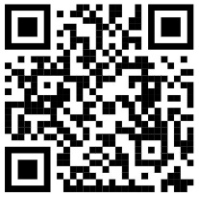

*https://youtu.be/vmShpcxi4Fo*

Note: For a more detailed visual step-by-step explanation of the data sorting and organization procedure, scan the QR code to view the video on the link provided.

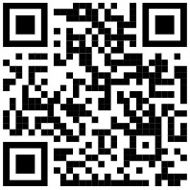*https://www.youtube.com/watch?v=XYiVcFmkDoY*

**Safety Precautions:**

* Avoid making contact with or touching electrical devices when your hands are wet.
* Only plug in the advised and recommended appliances on the system.
* Do not insert utensils and other thin metal objects into the outlet of the meter unit. This may lead to a person being electrocuted.
* Avoid “octopus” electrical connections, which can increase the risks of fire and other electrical-related accidents